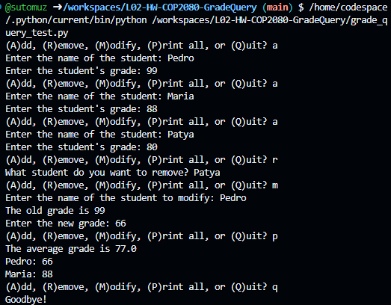

https://github.com/sutomuz/L02-HW-COP2080-GradeQuery.git

